UCHA WANTOWE
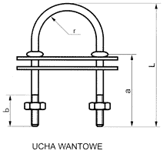

C | L | a | b | r | mm
5,0 | 45 | 20 | 15 | 12,5 | U5/45
6,0 | 55 | 30 | 20 | 12,5 | U6/55
6,0 | 65 | 40 | 20 | 12,5 | U6/66
8,0 | 65 | 30 | 20 | 17,5 | U8/65
8,0 | 85 | 45 | 25 | 17,5 | U8/85
10,0 | 98 | 50 | 40 | 22,0 | U10
12,0 115 70 40 22,0 U12
12,0 150 90 45 30,0 U12S

